Operation Manual

HMCOT VLF Hipot Tester
with Tan Delta Measurement
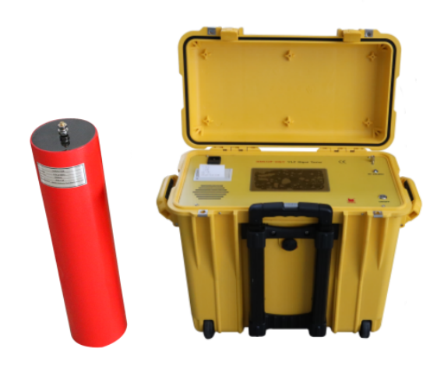

WUHAN GOLDHOME HIPOT ELECTRIC CO.,LTD
Tel.：+86-18627130886 Fax：+86-27-84620387
Email: goldhome01@cablehipot.com Web.: www.hvcablehipot.com
Add.: No. A25-1, Huading Mould Industrial Park, Hannan, Wuhan, Hubei, China

Contents

Contents 1
Part I: Product introduction 2
1.1 Advantage 2
1.2 Product specifications: Table 1 3
1.3 General technical indexes 3
1.4 Description and usage of integrated structure 3
1.5 Accessories of Series connection shown in the figure below 4
Part II: Operation instructions 5
2.1 Connection method 5
2.2 Introduction of test procedure 6
2.3 Operation instructions 6
Part III: Operation instructions for dielectric loss test (tgδ) 9
3.1 Why use VLF for dielectric loss test of cable 9
3.2 Introduction to VLF dielectric loss(tgδ) 9
3.3 General technical indexes of VLF dielectric loss (related to dielectric loss) 9
3.4 Structure of VLF dielectric loss test 9
3.5 Operation method of VLF dielectric loss test 10
3.6 How to eliminate the influence of cable surface leakage current on dielectric loss 12
3.7 Introduction to VLF dielectric loss test procedure 12
Part IV :DC Withstand voltage test 14
4.1 Main technical parameter 14
4.2 Operation method 14
Part V : Maintenance, Safety matters, Packaging and Transportation 14
5.1 Daily maintenance and safety 14
5.2 printer paper change method 15
5.3 Packaging and transportation 15

Part I: Product introduction

1.1 Advantage
This product adopts digital frequency conversion technology, single-chip microcomputer control, and the step-up, step-down, measurement and protection are fully automated. Due to full electronization, it has small volume and light weight. It adopts large screen color touch screen, which is clear and intuitive, simple to operate and display output waveform. The design index conforms to the national standard of general technical conditions for special test instruments for power equipment, Part 4: General technical conditions for ultra-low frequency and high voltage generators, which is simple and convenient to use. The main features are as follows:

    - single connection structure (one booster) shall be adopted for ultra-low frequency with rated voltage less than or equal to 50kV; The ultra-low frequency greater than 50kV adopts series structure (two boosters are connected in series), which greatly reduces the overall weight and enhances the load capacity. Moreover, both boosters can be used alone to achieve multi-purpose of one machine.

    - Current and voltage data are directly sampled from the high voltage side, so the data is accurate.

    - Intelligent comprehensive protection function: there is no need to set the current and voltage protection value. The instrument can calculate the overvoltage and overcurrent protection value according to the capacitance of the test object and the test voltage value. It can also protect the sudden change of voltage and current, so it can capture the discharge. The protection action time is less than 20ms.

    - High voltage cable 150KV is adopted for output, which is safe and reliable.

1.1.5 Since the closed-loop negative feedback control circuit is adopted, the output has no capacity rise effect.

1.1.6 Dielectric loss(tgδ) measurement function (for buyer’s option), which can measure the dielectric loss, capacitance and insulation resistance of the test object at the same time.

  - Product specifications: Table 1

Rated voltage | Frequency/Load capacity | Fuse | Product structure, weight and application scope
30kV  （Peak） | Auto Variable Frequency：0.1Hz-0.01Hz  Capacity：≦5µF | 8A | Controller: 40kg  Suitable for withstand voltage test of cables and motors ≤10kV
40kV  （Peak） | Auto Variable Frequency：0.1Hz-0.01Hz  Capacity：≦5µF | 10A | Controller: 40kg  Suitable for withstand voltage test of cables and motors ≤10kV
50kV  （Peak） | Auto Variable Frequency：0.1Hz-0.01Hz  Capacity：≦5µF | 15A | Controller: 40kg  Suitable for withstand voltage test of cables and motors ≤15kV
60kV  （Peak） | Auto Variable Frequency：0.1Hz-0.01Hz  Capacity：≦5µF | 15A | Controller: 40kg  Suitable for withstand voltage test of cables and motors ≤25kV
80kV  （Peak） | Auto Variable Frequency：0.1Hz-0.01Hz  Capacity：≦2µF | 20A | Controller (40KV): 40kg  Suitable for withstand voltage test of cables and motors ≤35kV
90kV  （Peak） | Auto Variable Frequency：0.1Hz-0.01Hz  Capacity：≦2µF | 20A | Controller (40KV): 40kg  Suitable for withstand voltage test of cables and motors ≤35kV

  - General technical indexes
1.3.1 Rated output voltage: 30kv-80kv, details see Table 1
1.3.2 Output frequency: automatic frequency conversion, range: 0.1Hz-0.01Hz
1.3.3 carrying capacity: see Table 1
1.3.4 Measurement accuracy: ≤ 3%
1.3.5 Voltage positive and negative peak error: ≤ 3%
1.3.6 Voltage waveform distortion: ≤ 3%
1.3.7 Operating conditions: indoor and outdoor; Temperature: - 10 ℃ - + 40 ℃;
Humidity: ≤ 85% RH
1.3.8 Input power supply: 220V ± 5%, 50Hz/60Hz. If the micro generator is used for power supply, the frequency conversion generator shall be used instead of the ordinary generator, because the unstable speed of the ordinary generator will make the boost abnormal and damage the instrument.

1.4 Description and usage of integrated structure
The all-in-one integrated machine can directly output 0-40kV, which is sutable for test Tan delta. If want to output higher voltage, additional 40kV booster can be connected in series, which can be increased to 80kV. The description is as follows:

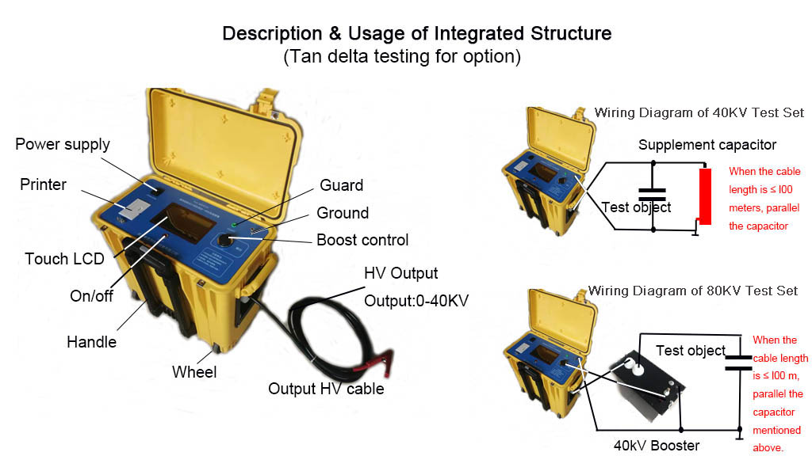

1.5 Accessories of Series connection shown in the figure below:
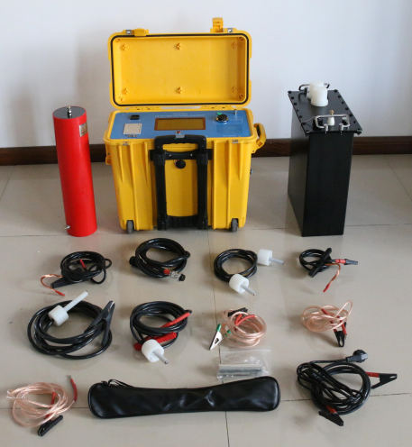
Sr. No | Description | Quantity
1 | Control unit | 1 | unit
2 | Booster | 1 | unit
3 | Capacitor, 0.04µF | 1 | unit
4 | 80kV HV cable | 1 | unit
5 | 40kV HV cable | 1 | unit
6 | Series connection cable | 1 | unit
7 | Control cable | 1 | unit
8 | Parallel cable for capacitor | 1 | unit
9 | Power supply cable | 1 | unit
10 | Earth cable | 3 | unit
11 | Shielding cable | 2 | unit
12 | Discharging rod | 1 | unit
13 | Print paper | 2 | unit
14 | Fuse | 2 | unit
15 | Manual | 1 | unit
16 | Factory test report | 1 | unit

Part II: Operation instructions

2.1 Connection method
2.1.1 Wiring method(referene) of single connection (≤60kV):
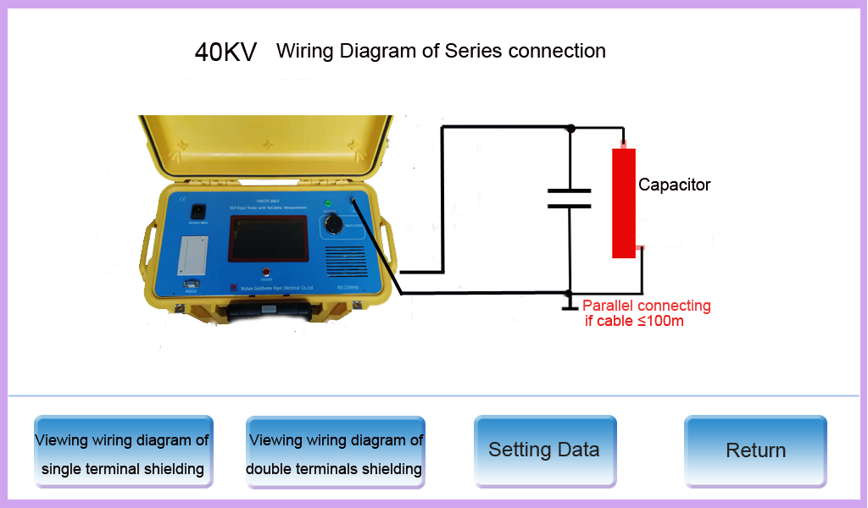

2.1.2 Connection method of VLF set when two-stage booster (Booster I & Booster II) is connected in series as follows:

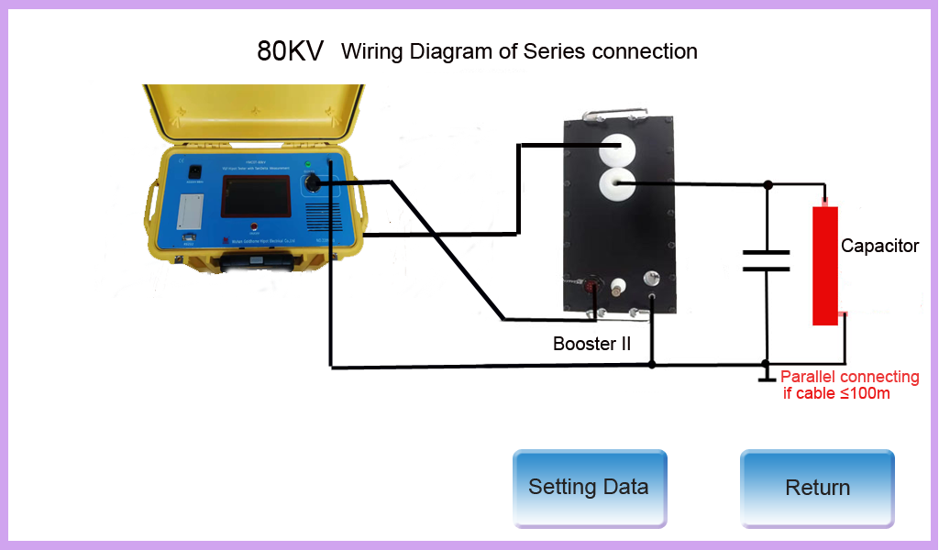

2.2 Introduction of test procedure (Q/ED116501-2004 Rubber Plastic Power Cable Handover and Preventive Test Procedure)
VLF is mainly used for AC withstand voltage test of cables within 35kV. The test voltage and test time for cables of different specifications are determined according to relevant regulations, and the contents of regulations in this regard are basically the same at home and abroad. The main contents of Q/ED116501-2004 code for intersection and preventive test of rubber and plastic power cables are summarized as follows for users' reference.

2.2.1 Test time: 60 minutes

2.2.2 VLF withstand voltage test voltages of various cables are as follows:
Rated Voltage  U0／U | Handover Test Voltage |  | Preventive Test Voltage
Rated Voltage  U0／U | Times | Voltage(kV) | Times | Voltage(kV)
1.8/3  3.6/3  6/6  6/10  8.7/10  12/20  21/35  26/35 | 3U0  3U0  3U0  3U0  3U0  3U0  3U0  3U0 | 5  11  18  18  26  36  63  78 | 3U0  3U0  3U0  3U0  3U0  3U0  3U0  3U0 | 5  11  18  18  26  36  63  78

2.3 Operation instructions
After connecting the field test system as described above, connect the power supply to enter the test. The home page of the touch screen of the controller is the wiring diagram selection.
Select the wiring diagram consistent with the actual situation to enter the parameter setting interface.

The test time, test voltage and step-up steps shall be modified according to the test requirements. Click the data to be modified, the numeric keypad will pop up and enter the required data.
In order to ensure safety, the system limits of input data:
Test voltage range:10kV to rated value;
Test time:1 to 99 minutes
After testing, parameters are automatically saved as the default value for next test.

Click "Test" to enter the test, and the instrument will raise the voltage to the set voltage in three cycles. Pre-test the test object in the first two cycles, judge whether the test object has low resistance fault, measure the capacitance of the test object, and then determine the appropriate frequency for voltage withstand test according to the capacitance of the test object. The system provides intelligent protection for the test process: overvoltage, overcurrent, sudden change of voltage and current, discharge, etc. When the test time is finished, the instrument will stop automatically, or you can directly click the "Stop" button to stop. The test object will be automatically discharged during shutdown.

After shutdown, the data can be printed or saved, and 90 groups test result can be saved circularly. The selected data record can be printed in the historical data query. The top line of the screen is the working status prompt of the instrument, including some fault information of the instrument.
Because there are touch key prompts and help information, you can follow the prompts without looking at the instructions. Before removing the wire, unplug the power cord, discharge the test object with a discharge rod, then short-circuit discharge, and then remove the wire.

If the tested cable is less than 100m and the instrument cannot output smooth sine wave voltage, the compensation capacitor can be connected in parallel at the test object end.

The four main operation interfaces are as follows:

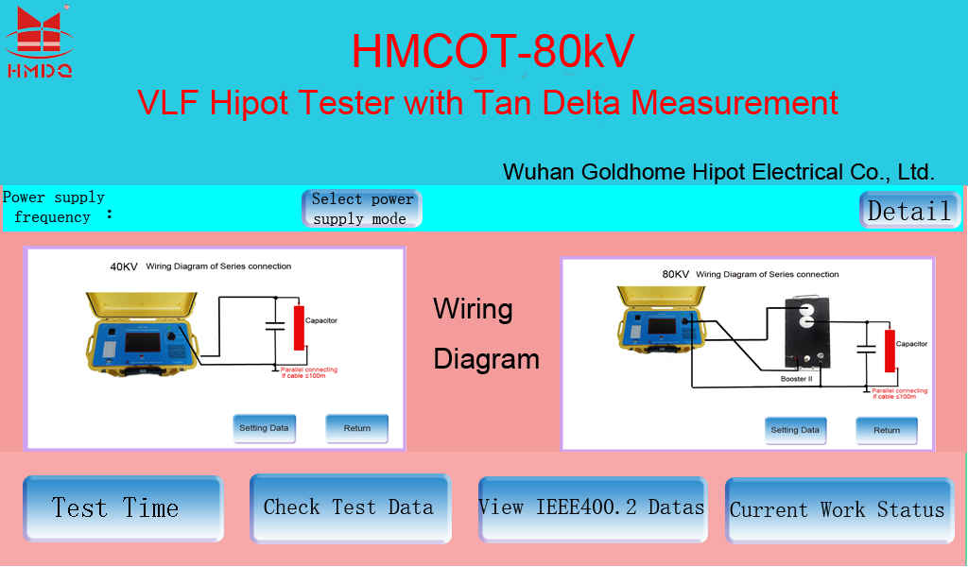

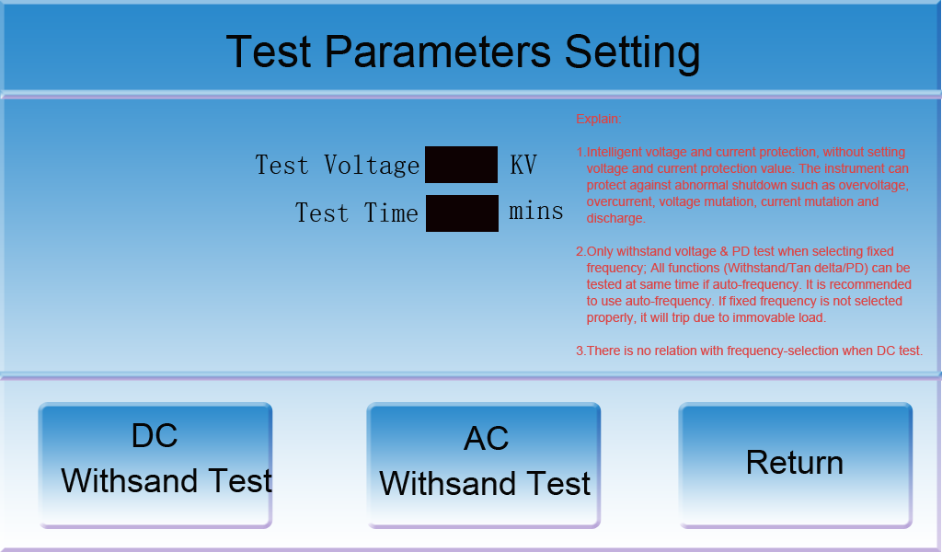
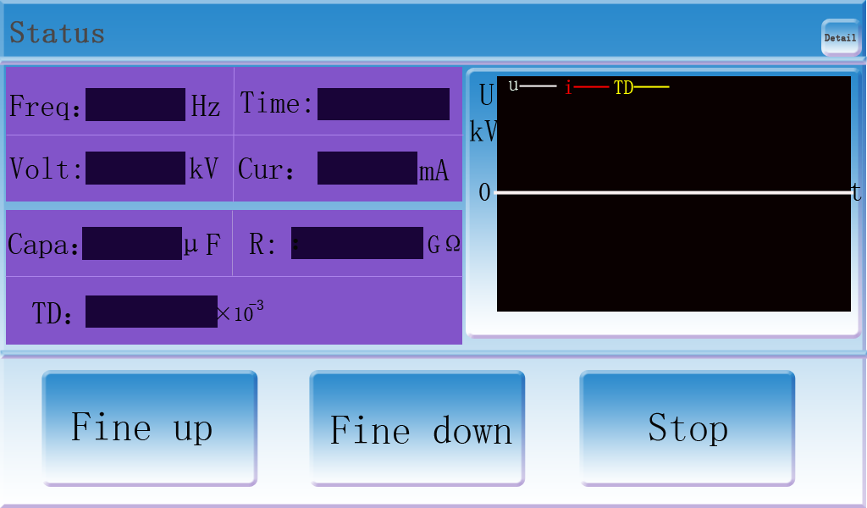
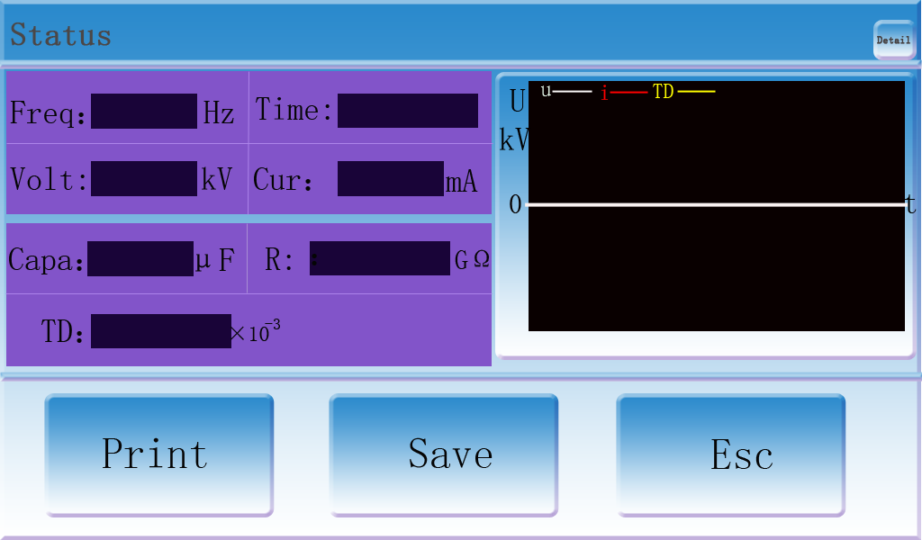

Part III: Operation instructions for dielectric loss test (tgδ)
Special note: the dielectric loss (tgδ) function for buyer’s option.

3.1 Why use VLF for dielectric loss test of cable?
Because the capacitance of the insulation layer of the cable is large, the power frequency dielectric loss instrument can not meet this test requirement. Ultra low frequency has strong load carrying capacity because of its low working frequency, which is suitable for dielectric loss test of cable.

3.2 Introduction to VLF dielectric loss(tgδ)
VLF Dielectric loss is a multifunctional cable tester, which can measure the dielectric loss, capacitance, insulation and withstand voltage test of cables. Since the electric parameter sampling device related to dielectric loss is installed in the ultra-low frequency booster and control box, the device has the advantages of small volume, light weight, simple connection and convenient use. It is a good assistant for cable field test and judging cable insulation performance.

3.3 General technical indexes of VLF dielectric loss (related to dielectric loss)
3.3.1 Test voltage range: 0~40kV
3.3.2 Dielectric loss test frequency: 0.1Hz
3.3.3 Dielectric loss measurement range: 0.01×10⁻³-655.36×10⁻³, the instrument will prompt:“﹥655.36×10⁻³” if >655.36×10⁻³ .
3.3.4 Dielectric loss resolution: ≤ 1x10⁻⁵
3.3.5 Capacitance measurement range: 0.001μF ~ 5μF
3.3.6 Celectric capacity resolution: 0.001μF
3.3.7 Current measurement range: 0–59mA
3.3.8 Measurement range of insulation resistance: 0-65..53GΩ . For values greater than 65.53GΩ, a prompt "greater than 65.53Ω" will be given.
3.3.9 Insulation resistance resolution: 10MΩ
3.3.10 RS232 communication interface (or USB)

3.4 Structure of VLF dielectric loss test
3.4.1 Structure of VLF dielectric loss
According to the specification Q/CSG1205027-2020 test method for ultra-low frequency dielectric loss of 6kv-35kv cable system, the maximum test voltage is 1.5U₀ of 35kV Cable, that is, 39kV. Therefore, we design the rated voltage of ultra-low frequency booster used to measure dielectric loss as 40kV, so as to meet the dielectric loss test requirements of all cables within 35kV. In order to give consideration to the voltage withstand test of cables, we recommend the following two products:

3.4.2 40kV single connection VLF dielectric loss set: it includes one 40kV booster and one control box. It is used for dielectric loss test of cables within 35kV and withstand voltage test of cables within 10kV. The connection mode of dielectric loss test is as follows:

3.4.2.1 Wiring diagram of single terminal shielding method
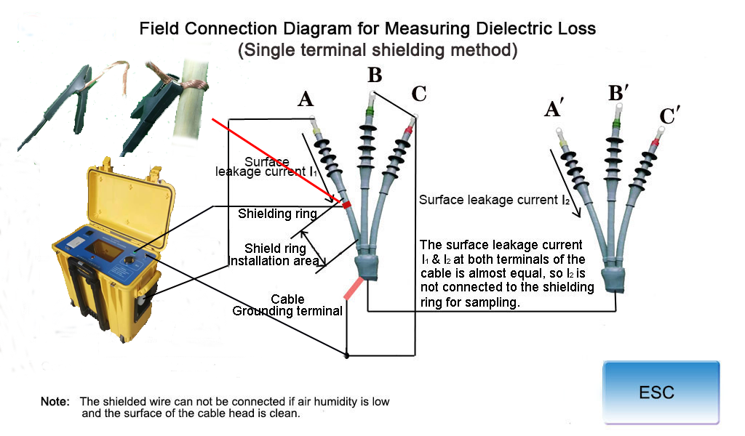

3.4.2.2 Wiring diagram of double terminals shielding method
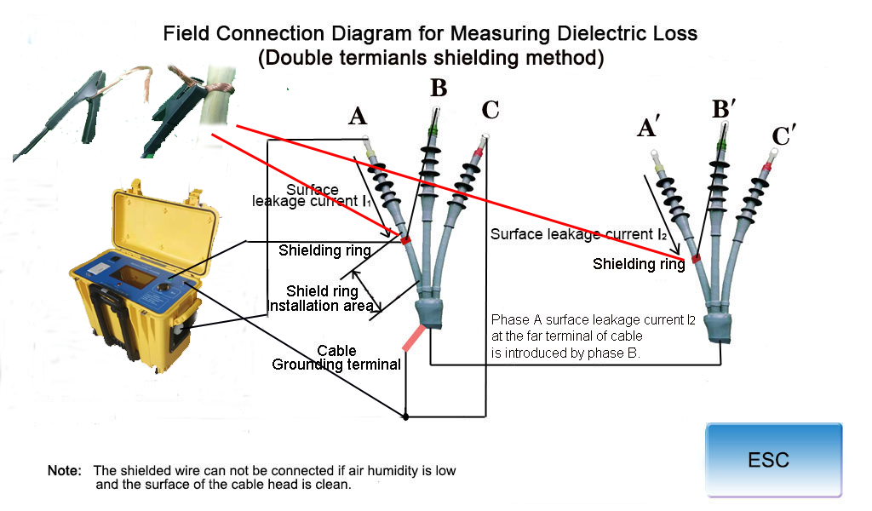

3.5 Operation method of VLF dielectric loss test:
After connecting the field test system as described above, connect the power supply to enter the test. The first page of the touch screen of the control box is the wiring diagram selection. The dielectric loss test wiring diagram shall be selected to enter the parameter setting interface. The test time and test voltage shall be modified according to the test requirements. Click the data to be modified, the numeric keypad will pop up and enter the required data. In order to ensure safety, the system limits of input data:
Test voltage range:3KV to rated value;
Test time:1-99 minutes. Test time is a useless parameter in dielectric loss test, but it will cause shutdown. Therefore, in order to avoid accidental shutdown, the time can be set larger.
Number of boosting steps is also a useless parameter and does not need to be modified.

Dielectric loss test is carried out according to the fixed procedure. After the test, this parameter will be automatically saved as the default value for next test.

Click " tgδ test" to enter the test. The instrument enters the self-test firstly. Self-test is to pre test the test object and calibrate the instrument itself. The self-test time is related to the length of the cable. The longer the cable, the longer the self-test time, it is 1 to 5 minutes waiting, you need to wait patiently. After self-test is completed, it will automatically enter the dielectric loss continuous test, and the dielectric loss, capacitance and insulation resistance can be measured at the same time. The data will be updated once every cycle (10 seconds). The more measurement, the more stable and accurate value technology designed. After several measurement cycles, the data will become very stable, and you can stop reading. The system provides intelligent protection for the test process: overvoltage, overcurrent, sudden change of voltage and current, discharge, etc. The test object will be automatically discharged during shutdown. After shutdown, the data can be printed or saved, and 90 groups can be saved circularly. The selected data record can be printed in the historical data query. The top line of the screen is the working status prompt of the instrument, including some fault information. Because there are touch key prompts and help information, you can follow the prompts without looking at the instructions. Before removing the wire, unplug the power cord, discharge the test object with a discharge rod, then short-circuit discharge, and then remove the wire. If the length of the tested cable is less than 100m and the instrument cannot output smooth sine wave voltage, the compensation capacitor we supplied can be connected in parallel at the terminal of test object and "Add Compensation Capacitor" can be selected on the parameter setting interface, so that the influence of compensation capacitor will be deducted from the test results. The compensation capacitor must be from GOLDHOME, because the parameters of this capacitor are supplied by GOLDHOME. The four main operation interfaces are as follows:

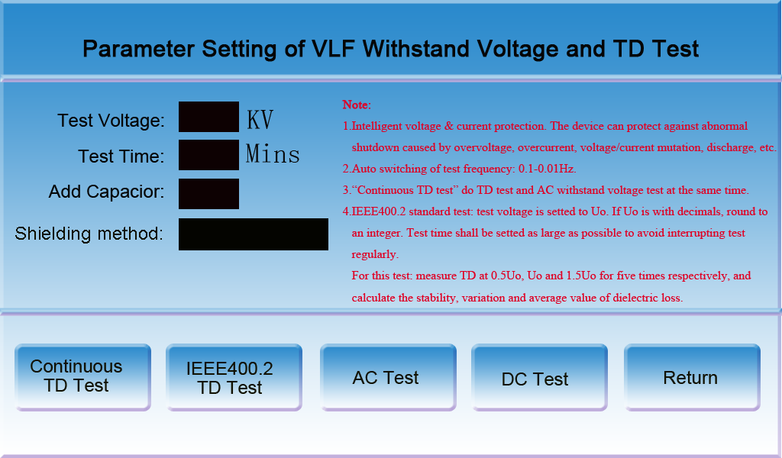

3.6 How to eliminate the influence of cable surface leakage current on dielectric loss:
When the air humidity is high or there is dirt on the surface of the cable end, leakage current will be formed on the cable surface, which will increase the dielectric loss value and affect the judgment of the insulation performance of the cable body. Therefore, this effect should be eliminated in dielectric loss test. The method is to wind a shielding ring around the lower half of the cable’s head and lead it to the shielding terminal of control box with wire. Because there is surface leakage current at both ends of the cable, both sides should be measured theoretically, but the measurement at the other end is obviously inconvenient. In order to simplify this problem, we regard the leakage current at both ends as approximately the same, measure only the leakage current at one end, and deduct twice the leakage current during dielectric loss test. The wiring method is shown in the field wiring diagram of dielectric loss above. If the air humidity is low and the surface of the cable end is clean, the shielded wire may not be connected.

3.7 Introduction to VLF dielectric loss test procedure (Q/CSG1205027-2020 VLF dielectric loss test method for 6kv-35kv cable system)
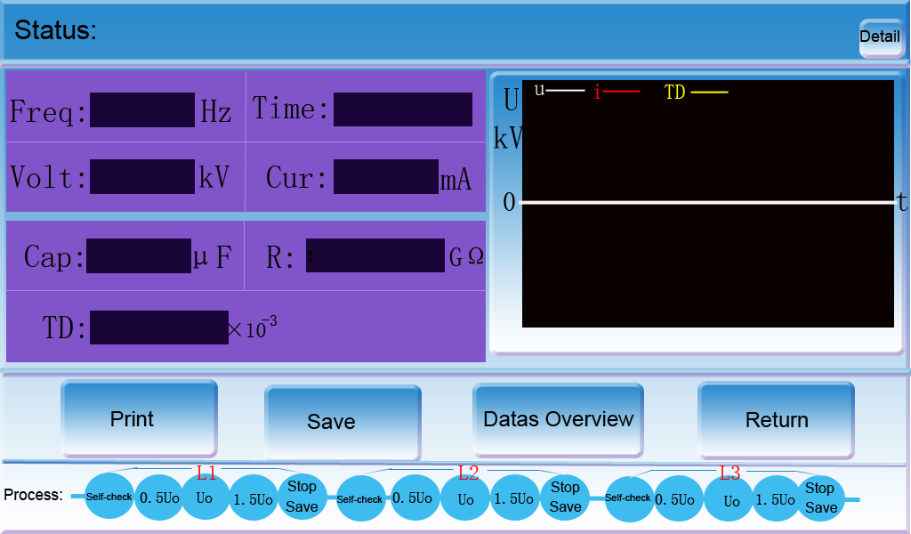

The main contents of judging the insulation performance of cables with dielectric loss data are summarized as follows for reference only:

3.7.1 Test points of dielectric loss: 0.5U₀, U₀, 1.5U₀
3.7.2 Treatment opinions for dielectric loss test value of VLF cable.
Cable insulation aging state  Evaluation conclusion | Average dielectric loss U₀  （10⁻³） |  | Dielectric loss variation  Difference of 1.5U₀ & 0.5U₀  （10⁻³） |  | Dielectric loss stability  Standard Deviation of U₀ dielectric loss value  （10⁻³）
Normal state | ＜4 | and | ＜5 | and | ＜0.1
Attention state | 4 - 50 | or | 5 - 80 | or | 0.1 - 0.5
Abnormal state | ＞50 | or | ＞80 | or | ＞0.5

Explain:
Taking the average value of dielectric loss, the change of dielectric loss and the absolute value of dielectric loss stability as the evaluation index, or according to the results of comparison with historical data, the cable insulation status can be divided into the following three types:
a) Normal state: no maintenance action is required.
b) Attention state: further testing is recommended. The cable shall be retested regularly, and the recommended time interval is 1 year,
If there is no obvious change in the retest results, it can continue to be put into operation; If the retest result has become significantly larger, or the result value has entered the required value
To the scope of maintenance action, the defective position of the cable line shall be checked immediately and replaced in time.
c) Abnormal state: maintenance action is required. The defective position of the cable line shall be checked immediately and repaired or replaced in time.

Part IV :DC Withstand voltage test

4.1 Main technical parameter
4.1.1 Output rated voltage: DC rated voltage is equal to VLF rated voltage,same as 1.3.
4.1.2 DC current range: 0-2000μA
4.1.3 DC current resolution: 1μA
4.1.4 DC current accuracy: 3%

4.2 Operation method

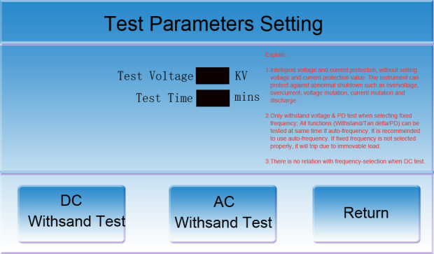
The operation method is the same as that of VLF AC test. Enter the following parameter setting interface, set the test voltage and test time, and click "DC test" to start boosting. The timer stops automatically when it is completed. Click the “Stop” button to stop immediately.

Part V : Maintenance, Safety matters, Packaging and Transportation:

5.1 Daily maintenance and safety
Various faults will occur in the test of Very low frequency. Some
peripheral faults can be repaired by the user. For example, the plug and wire of the connecting line are easy to be disconnected, which can be judged by the resistance gear of the multimeter. If there is no display, check whether the fuse is burnt out and whether there is a problem in the power input circuit. For internal problems, contact the production unit for maintenance.
The VLF test device belongs to the equipment generating high voltage, and
its surface shall be kept clean, waterproof and dustproof. The connection
sequence is to connect the test line first and then the power line. After
the test, fully discharge the test object before removing the wire. The
removal sequence is to unplug the power cord first and then remove the
test line.

5.2 printer paper change method
Pull the front cover button to open the front cover of the printer, take
out the remaining paper core, put in a new paper roll, pull out part of
the paper head, put it in the middle position, and close the front cover,
as shown in the following figure:
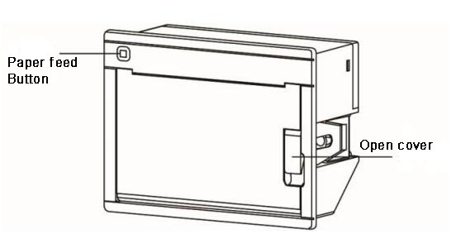
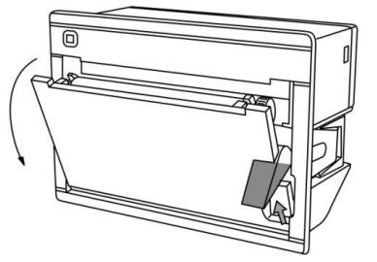
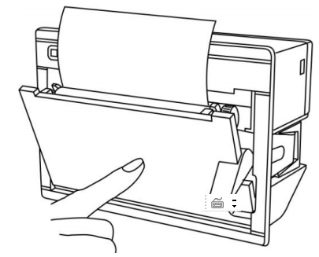
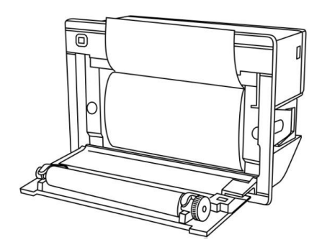

5.3 Packaging and transportation:
Booster and accessories shall be packaged in aluminum alloy box. For
long-distance transportation, the control box and aluminum alloy box
shall be packed in wooden cases. Prevent side lying, inversion and
waterproof during transportation. The packing boxes used are shown in the
figure below:

